Interaction networks predict optimal harvester ant foraging behavior

Ethan Sudman  
Summer 2021  
ethanjsudman@lewisu.edu

*Abstract*

Network Science is an emerging interdisciplinary field that uses the tools of statistics, graph theory, and linear algebra to represent relational data. By representing ants and food locations in a graph, we can predict both the cast of the ant and their optimal foraging behavior. We will demonstrate that graph metrics like Hubness and Authority, common algorithms like PageRank, and adversarial learning techniques like struc2vec can predict when ants become foragers. Additionally, it can predict the foraging behavior of ants and help understand baffling points about the optimality of foraging behavior.

*Index Terms*— Optimal Foraging Theory, network science

# INTRODUCTION

Ants are highly social insects that operate without central control or globally available information. Prior research by Gordon *et. al.* demonstrates that foraging behavior among ants and other social insects is heavily driven by interactions between foragers, dictating everything from where to look for food to what kinds of food to prefer. [1] Evidence strongly suggests that foragers have a particular “smell” that is distinct from other casts of ants; additionally, social insects appear utilize scent cues left by other foragers to recognize which kinds of food to prefer. [2]

Optimal Foraging Theory is predicated on the idea that evolutionary pressures will naturally drive organisms towards optimal foraging behavior over time. In an environment where there are multiple colonies (or even multiple species) competing for the same food supply, this will likely be User Equilibrium, whereas in cases where there was limited competition for a particular kind of food it could presumably be closer to Global Optimum. (Even in this case, however, we must consider the possibility that species evolved in such a way as to avoid competition with other species; in this case, what appeared to be a global optimum may, in fact, have evolved due to that being a User Equilibrium).

A major consideration for any model is that the reproductive unit is the colony as a whole, *not* the individual ant, and the reason is the following: the vast majority of ants are sterile females. A Leaf-Cutter Ant colony can consist of up to 10 million sterile female workers, up to 5 fertile female queens, and some number of males who mate once and die shortly thereafter. Thus, natural selection strongly prefers behaviors that are optimal for the colony as a whole, not just for individual ants.

# Optimal Foraging Behavior

The Red Harvester Ant (*Pogonomyrmex barbatus*) is native to the deserts in the southwestern United States. Their preferred food source is seeds, which is also their primary source of hydration (due to the moisture that occurs in the fat stored in the seeds). Foraging behavior is strongly influenced by both the ongoing need for food and water and by the need to minimize moisture loss brought on by the desert heat.

Until the recent introduction of invasive species like the Argentine Ants, the Red Harvester Ants did not face significant competition for food within their foraging range; ranges of individual colonies do not overlap very much [3]. (This is likely a case of User Equilibrium, as demonstrated in the cited paper).

Many species of ants, including Red Harvester Ants, rapidly increase their foraging activities in response to successfully returning foragers [1]. This makes sense for ants that target food that moves – after all, if you’re trying to steal food from a picnic, you generally want to steal as much as you can before the humans leave. This behavior is somewhat harder to account for in the case of Red Harvester Ants, however, given their non-overlapping food ranges and largely stationary food sources.

Given the costs associated with unsuccessful foraging in the desert, it is clearly adaptive for harvester ants to regulate their foraging rates based on the probability of success (and based on other factors, such as the season [2], weather [4], and probability of encountering other competing ants [3]); however, it seems quite strange for them to increase as quickly, and to the degree, that they do.

Exactly why Red Harvester Ants behave in this way will be one of the major themes of this project. When considering the optimality of this behavior, we encounter a number of possible approaches. On the one hand, it can be modeled as a dynamical process on a network. This encompasses a number of possible approaches; for example, models inspired by statistical physics have gained significant traction within the research community. In particular, the Ising Model (which was originally used to predict ferromagnetic phase transitions) has found many applications outside of physics, as described by Barrat *et. al.* [5] In these models, the behavior of the system as a whole is described as a function of the microscopic behavior of the constituent parts – in particular, a system is composed of a lattice (or, in this case, a network) of individual particles that can carry either a negative or positive spin.

In this case, the degree distribution of the graph representing ant interactions is highly heterogeneous. Based on an analysis of the number of interactions in one day of data from [7], we receive the following histogram:

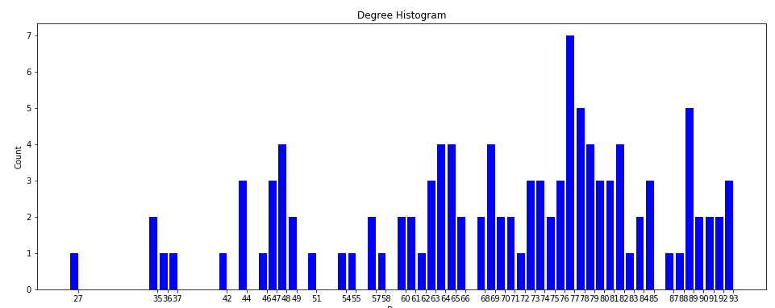

This is clearly far from a uniform (or even normal) distribution of degrees. Additionally, looking at the betweenness centrality for individual ants (from the same data set):

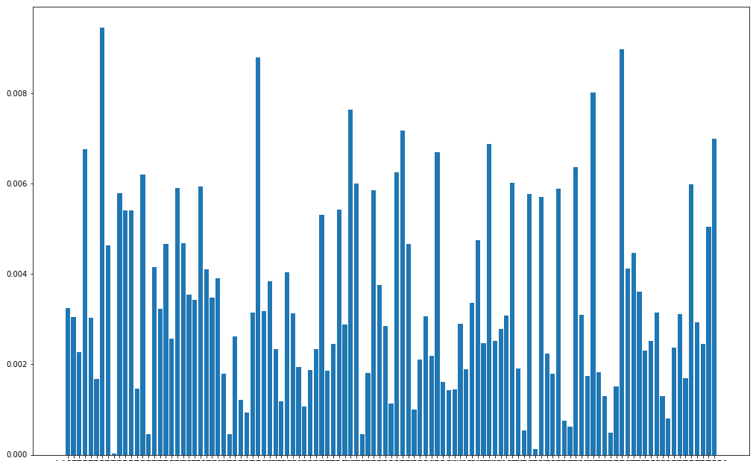

At first glance, this appears not to be normal. However, if we sort this and graph again, this seems much closer to normally distributed:

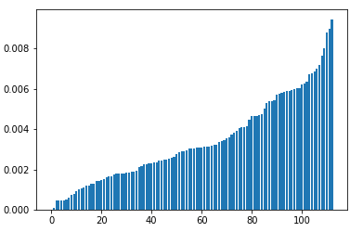

Additional tests will be required to determine whether this is normally distributed. (Note that the second graph is rather different than the first one in that the first graph is a histogram that contains counts of the number of ants with a specific degree distribution, but the second graph represents actual value of individual ants’ betweenness centrality).

Note that these graphs are *not* restricted to interactions with other foragers, and if we were to make such a restriction the result may be quite different.

This type of approach can be additionally combined with approaches such as the SIR model from epidemiology, where in place of traditional phase transitions the constituent parts move between different “buckets” or “components” in a way that is typically represented by a differential equation representing the relationship of each “bucket” to all others. For example, in the SIR model, a large number of individuals are initially Susceptible to a disease with a small number of individuals being initially infected. From there, individuals can be moved from Susceptible to Infected, or from Infected to Removed. Naturally, there are many variants of this model (such as SIS, in which infected individuals become susceptible again; this model could be particularly relevant to foraging, where “Susceptible” ants are quiescent foragers and “Infected” ants are active foragers), and there could hypothetically be any number of “buckets.”

More recently, temporal networks have also garnered significant attention, as has agent-based modeling, which is based on a number of individual agents who follow some specified rules and interact with each other. The system is studied for emergent behavior.

Finally, game theory has been utilized by some researchers as a means to explain foraging behavior, such as how individual territories and foraging ranges are established. While it is not immediately obvious why the behaviors of animals, who generally lack abstract reasoning abilities[1], could be predicted by game-theoretic models, it seems evident that natural selection would systematically favor animals (and insects) who consistently followed best-response strategies to other animals’ strategies. We can quickly confirm this by considering the negation as a thought experiment: would an animal that consistently followed strictly dominated strategies in “games” with other animals be likely to survive for very long? In fact, such an animal would likely be eliminated by natural selection.

By way of example, the fact that Harvester Ants typically have non-overlapping foraging ranges was previously discussed; this likely did not occur by chance but rather due to the fact that having non-overlapping ranges enhances survivability for the colony – i.e. the best response to another colony foraging in a particular area is usually avoidance. In fact, the fact that they sometimes do fight suggests the existence of a mixed-strategy Nash Equilibrium, and the reason is the following: if either fighting or not fighting strictly dominated the other strategy, the Nash Equilibrium must be for both colonies to follow the strictly dominant pure strategy. While the full exploration of this particular topic is out of scope for this project, it would be a fascinating topic for future exploration; additionally, these facts will likely prove to be highly useful to this project.

Ant foraging and food locations can be represented as a graph [6]. While the foraging networks themselves can be studied for optimality, this particular data set will primarily be used to tune and validate our models.

This project will focus in particular on ant behavior as a dynamical process on a network. The Ising Model, the SIS model, and the SIR-inspired model will both be adapted to examine how colonies as a whole forage, and we will attempt a tentative answer for why this behavior might be optimal.

In the Ising Model for the project, the positive and negative spin will represent active and quiescent foragers, effectively forming a Boolean Network; for the SIR model, we will consider several possible compartments and explore the implications of modeling with each:

* Ants of another cast (e.g. nurses) that could hypothetically become a forager (i.e. excluding queens and males, which could never become foragers). We will ignore the case of foragers joining other casts, since foragers are typically the oldest ants in the colony and it is unusual for them to “switch back” to being a member of another cast.
* Removal due to death. This is useful in the case of, for example, fighting between colonies.
* Quiescent foragers
* Foragers actively searching for food
* Foragers returning with food
* Foragers that just returned with food
* Foragers returning without food (i.e. unsuccessful foragers)

Our initial models will assume infinite food availability, but may also be expanded to account for limited food availability.

# Cast Selection

Larger ant colonies tend to have a high degree of division of labor. Research by Mersch *et. al.* [7]tracked six separate colonies over 41 separate days and found three distinct behavioral repertoires, with much higher within-group interaction than between-group interaction. This graph of interactions is highly informative, and various metrics can be used to predict which ants will fall within which group. Merely by applying Random Forest or Neural Network algorithms to two graph metrics on the data set from the study, Hubness and PageRank, we were able to predict the behavioral repertoire of the ants with 55% accuracy, which is considerably better than random chance. Hubness/Authority Ratio as a graph metric has been studied as a means of classifying, for example, neuron types in the brain. [8] This data set will be a primary data set used in this project. Several of the key questions include:

* Which graph metrics are the most predictive of the current behavioral repertoire of the ant? Unfortunately, this data set is undirected, so the Hubness/Authority Ratio is 1 by definition (since there is no distinction between in degree and out degree); however, Hubness and PageRank will be of particular interest, and the struc2vec [9] [10] adversarial learning algorithm will also be considered for comparison.
* Which graph metrics predict when an ant will change behavioral repertoire?
* Does this graph show preferential attachment?
* Are community detection algorithms effective for this graph?
* Can the interaction network be categorized as a scale-free or small-world?
* How efficient is the overall network? (Additional data on this is available as part of [11]).

# Project Goals

The primary premise of this project is that ant colonies function without any central control or central source of information, and that information is largely spread by direct and indirect interactions with other ants, such as chemical trail networks.

Note that many studies have suggested a strong role for environmental cues for behavior, and perhaps even cues from other types of animals, in addition to interaction with other ants; for example, chapter 4 of [2] offers compelling evidence of seasonal patterns in Ponerinae ants. However, detailed consideration of these factors will be out of scope for this project, which will focus on interaction patterns.

There are two primary goals for this project.

First, we will determine which graph metrics are the most predictive of the primary behavioral repertoire of ants (especially when ants become foragers).

Secondly, we will see whether models such as the Ising Model and SIS models can accurately predict when foragers will leave the nest. Of particular interest is whether these models provide clues as to why Harvester Ants leave the nest so rapidly in response to the successful return of foragers, given that this appears unnecessary in their particular environment. In particular, we will consider whether natural selection would “directly” select for this behavior or if it’s merely a byproduct of some other aspect of their foraging.

# Major Deliverables

The primary deliverables will consist of the following:

* Ising Model to determine when foragers leave the nest
* SIS model to predict when foragers leave the nest (where S is quiescent foragers and I is active foragers)
* SIR-inspired model to predict when foragers leave the nest, tentatively including the following compartments:
  + Ants of another cast (e.g. nurses) that could hypothetically become a forager
  + Removal due to death. This is useful in the case of, for example, fighting between colonies.
  + Quiescent foragers
  + Foragers actively searching for food
  + Foragers currently returning with food
  + Foragers that recently returned with food
  + Foragers returning without food (i.e. unsuccessful foragers)
* Analysis of graph metrics and their ability to predict behavioral repertoire of ants. Graph metrics that will be evaluated include:
  + Betweenness Centrality
  + Inter-group interaction
  + Hubness, Authority, and Hubness/Authority Ratio
  + PageRank
  + Degree
  + Struc2Vec
  + Community detection algorithms

Items that were considered (but will be left for future works) include:

* Agent-based modeling to represent the way that ants forage. Rather, we will assume that ants are essentially homogeneous (except for degree distribution).
* Game theoretic model of foraging behavior. (For the purpose of this project, I will, however, assume that ant colonies will reach a Nash Equilibrium state with each other due to natural selection).

# Conclusion

## Given the lack of central control and global information, as well as evolutionary pressures for the colony as a whole to reach User Equilibrium with surrounding colonies, ant interaction networks are of strong interest in studying insect biology. This project intends to explore the ways in which this data can be fully utilized.

References

1. Gordon, D. (2010). *Ant encounters: Interaction networks and colony behavior*. Princeton, NJ: Princeton University Press.
2. Jarau, S., & Hrncir, M. (2019). *Food exploitation by social insects: Ecological, behavioral, and theoretical approaches*. Boca Raton: CRC Press/Taylor & Francis Group.
3. Adler, F., & Gordon, D. (2003). Optimization, conflict, And Nonoverlapping foraging ranges in ants. *The American Naturalist,* *162*(5), 529-543. doi:10.1086/378856
4. Gordon, D. M. (2013). The rewards of restraint in the collective regulation of foraging by harvester ant colonies. *Nature,* *498*(7452), 91-93. doi:10.1038/nature12137
5. Barrat, A., Barthélemy, M., & Vespignani, A. (2013). *Dynamical processes on complex networks*. Cambridge: Cambridge University Press.
6. Lopes, J. F., Brugger, M. S., Menezes, R. B., Camargo, R. S., Forti, L. C., & Fourcassié, V. (2016). Spatio-Temporal dynamics of Foraging networks in the Grass-Cutting Ant ATTA bisphaerica FOREL, 1908 (Formicidae, Attini). *PLOS ONE,* *11*(1). doi:10.1371/journal.pone.0146613
7. Mersch, D. P., Crespi, A., & Keller, L. (2013). Tracking individuals shows spatial fidelity is a key regulator of ant social organization. *Science,* *340*(6136), 1090-1093. doi:10.1126/science.1234316
8. Szczurek, P., & Horeni, M. (2018). Using link analysis algorithms to study the role of neurons in the worm connectome. *2018 IEEE 32nd International Conference on Advanced Information Networking and Applications (AINA)*. doi:10.1109/aina.2018.00100
9. Kikuta, S., Toriumi, F., Nishiguchi, M., Liu, S., Fukuma, T., Nishida, T., & Usui, S. (2020). Framework for role discovery using transfer learning. *Applied Network Science,* *5*(1). doi:10.1007/s41109-020-00281-3
10. Ribeiro, L. F., Saverese, P. H., & Figueiredo, D. R. (2017). Struc2vec. *Proceedings of the 23rd ACM SIGKDD International Conference on Knowledge Discovery and Data Mining*. doi:10.1145/3097983.3098061
11. Buhl, J., Hicks, K., Miller, E. R., Persey, S., Alinvi, O., & Sumpter, D. J. (2008). Shape and efficiency of wood ant foraging networks. *Behavioral Ecology and Sociobiology,* *63*(3), 451-460. doi:10.1007/s00265-008-0680-7

1. Two possible exceptions include non-human primates like gorillas, several of which have been taught sign language as part of animal intelligence experiments, and bonobos (which are closely related enough to humans to have some overlap in facial expressions, which Darwin, Ekman *et. al.* demonstrated are universal to all humans regardless of culture and likely have a strong genetic basis). Perhaps more surprisingly, several other mammals also pass the mirror test for self-recognition and show signs of high degrees of intelligence, such as elephants and dolphins. Another curious case is the African Gray Parrot, several of which have also been trained to make sophisticated use of human language as part of experiments. It should be noted, however, that these are examples of Verbal Behavior, which has been demonstrated by Chompsky *et. al.* not to adequately represent human language acquisition. (The alternative model proposed by Chompsky is known as “Universal Grammar” and, at risk of oversimplifying, holds that humans acquire language by activating an innate ability, not merely by imitation of adults or by having appropriate verbal behaviors rewarded by adults responding in desirable ways.